MSFS CamControl V 0.70.0.70

See (V0.70) indications for updates from the previous version (V0.65)

# Control the Sim Camera from an independent App

* The App supports many Cam functions in a more condensed space than the MSFS Cam Window
* However at the time of writing many functions in SimConnect are not (yet) working – so this App is to be considered as Work In Progress
* As soon as MSFS supports more it will be added to the App

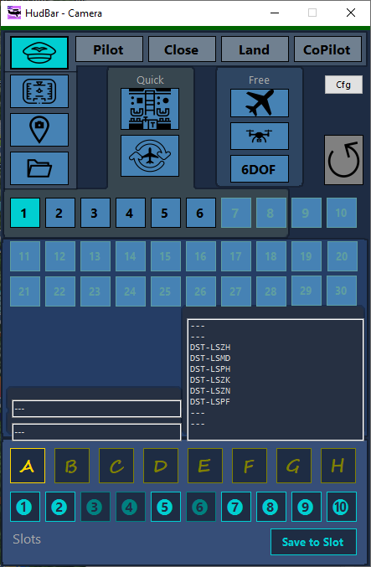

It is modelled to match the Views available in the Sim Camera Tool.

## V 0.70 News

* FlyBy Helper
* Custom Camera selection
* Fixed 6DOF Pitch direction – was changed in one of the SU’s
* Some GUI redesign

## Old News

…

Content

Control the Sim Camera from an independent App 1

V 0.70 News 2

Old News 2

Usage of the Standalone App 3

Setup 3

Limitations 3

Camera Management Console 4

6DOF Camera 5

Selecting Custom Cameras (new V0.70) 5

FlyBy Helper (new V0.70) 6

Key Setup (new V0.70) 7

Distributed Contents: 8

Appendix: 9

Issue Reporting: 9

# Usage of the Standalone App

* Deploy the release all zip content in a folder (no installer provided or needed)

Best is to start MSFS first, then the CamControl   
Start MSFS2020 first and once the Main Menu is shown

* Start FS20_CamControl.exe
* It attempts to connect to the Flight simulator in 5 sec intervals, but shows a red line on top while it cannot connect

# Setup

In order to use the new functionality you have to setup the key-bindings in the Cam Window first, and only once…

See **Key Setup** Chapter below on how to do it.

# Limitations

* With the new features the Application will sometimes issue keystrokes to the Simulator window.   
  This might be detected by some virus checkers or other security programs – I did not encounter it so far.  
  In such cases you may want to add the App to the exclusion list of such security programs.

*Disclosure: The Camera App sends keystrokes for the 10 Custom cameras when selecting the custom cam, and 6 Drone movements (up, down, left, right, forward, backward) when using the FlyBy Helper.*

* I appears that sometimes commands are ignored by the Sim.  
  This is due to the time the sim needs switching cameras and views. The Sim then simply ignores or ‘forgets’ commands issued by outside programs.  
  If you encounter, just try again and it may work. At least I could not find a way to force the Sim to do things…

# Camera Management Console

A separate Window to control the Camera Views.

It is modelled to match the Views available in the Sim Camera Tool.  
*Hint: to see what is what open the Sim Camera tool and hit some buttons in the new Console – the Sim Tool will update accordingly*

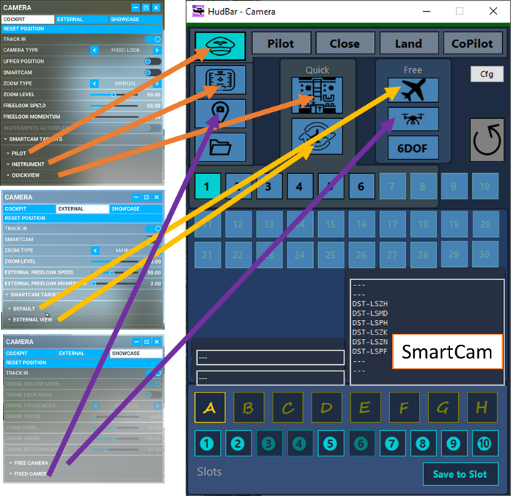**Open** the Console via RightClick Menu **Camera…**

**Close** it with the X top right

The **View Icons** match according to the illustration to the right.

**Quick** Views are named as such.

**Free** Views are the **Drone** and the **External** Default Cameras

The **Cockpit** View goes with **Pilot**, **Instrument** and the **Quick** View.  
For the Pilot the 4 fixed positions are named (Pilot, Close, Land, CoPilot)

Except for the Free Views the preset camera POI is selected with a **numbered button 1..30**.   
Quick Views have 8, other Views according to the configuration file of the aircraft.

Starred ☼ Views

**Up to 80** saved views are available in the lower part of the Window

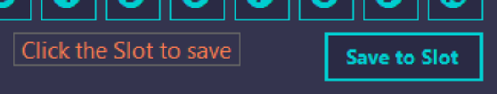You may **save** the **current** view into one of the 8 Folders (**A..H**) - Slots (❶..❿), only the View is saved, not position, angle etc. when changed.

To **Save**, click ‘**Save to Slot’** and then the **Slot** to save to. To **Cancel** Save, click the Save button again.  
The red advice should then go away.

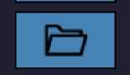To **Recall**, click the **Folder/Slot** while not in Save mode.

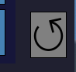**Custom Views** can now be recalled by using keyboard injection (new V0.70)  
Be sure do configure the keys when first using it.

Reset View

Sometimes it is helpful to **Reset** a View

HotKey Binding for the HudBar Version

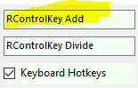**Show/Hide** can be assigned to a **keyboard shortcut**. It is also mapped to a MSFS command (ADF2_FRACT_DEC_CARRY), both must be enabled in Configuration (see Hotkeys above).  
There is no label, it is two above the CheckBox for Keyboard Hotkeys (see Tooltip)  
Here I assigned it to <Right Control> + <Numpad+>, default it is empty.

NOTE: Sometimes switching Views or POIs may not change the first time, just hit the button again.  
I assume there is still quite a bit of WorkInProgress ™ by Asobo… as the Sim Tool does the same.  
Also note that I cannot retrieve the names of the POI views as shown in the Sim Window – we have to live with the numbers …

# 6DOF Camera

This is *undocumented* in the MSFS SDK but works in SU14 …  
*ASOBO mentioned it is no longer supported any may no longer work in future updates … let’s see…*

The 6DOF Camera is a gimballed camera firmly attached to the aircraft at position 0/0/0 which is usually close to the pilot seat.   
Note: the camera is really attached to the plane and will follow ALL movements of the aircraft, especially when on a runway it shakes quite a bit...

One can adjust the position of the camera relative to its origin in X,Y,Z which is front, back; above, below; and left, right of that center point.  
The gimbal, or viewpoint of the camera is controlled by heading (left, right), pitch (up, down), and bank values.

! 6DOF Camera Positions can be saved to Slots and recalled like other camera positions (see Starred Views).  
For the 6DOF camera also the number values are saved and restored.

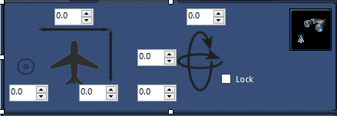

When selecting the 6DOF cam the button area is overlaid by the numeric controls shown above.

Using the numeric controls one can adjust the **position** and **viewpoint** (gimbal) of the camera.

* On the left side is the cam position (the circle is up, down movement)
* On the right side the viewpoint (gimbal)
* Checking **LOCK** will maintain the viewpoint towards the aircraft while moving the camera position
* The button to the right will set a ‘look down’ viewpoint either left or right down

Numeric controls can be clicked, clicked and held, or accept a number entry.  
The value range is +-500.0 for the position which is an increment of about 10cm (4 inch) and +-180.0° for the viewpoint.

*Note: the MSFS Camera Dialog show does not support this mode but you still can revert to any other cam view if you wish (need) to do so.*

# Selecting Custom Cameras (new V0.70)

It is now possible to select custom cameras i.e. the ones you saved into slot 1..9, 0

The slots are selected using the index buttons 1..10, where 1..9 relate to custom camera 1..9 and the number 10 index calls custom camera 0

The **Key Setup** is required to have this work properly.

Technical stuff…

As the Sim API custom cam selection does not work and no due date is assigned to this bug by ASOBO;  
a workaround is implemented now.  
It is done by issuing key strokes to the Simulator Main Window.  
The Sim Window is activated and then keystrokes are sent to the active window (that is how Windows allows it).

# FlyBy Helper (new V0.70)

Also known as poor man’s Flyby.

The Drone Camera is used to showcase a fly by.

Here is how it can be done manually.

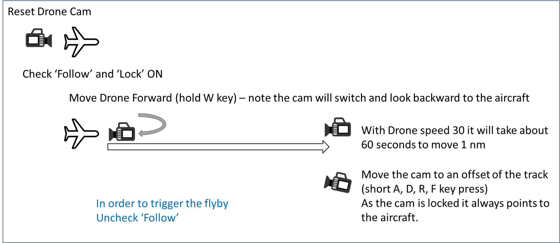

The App will perform those tasks for you and take in account how far out you want to have the camera and if the aircraft is climbing or descending.  
You need then only to hit the **FlyBy button** to let the aircraft passing by.  
You may use **Zoom** to get closer to the aircraft if needed.

The **Key Setup** is required to have this work properly.

FlyBy Helper GUI:

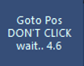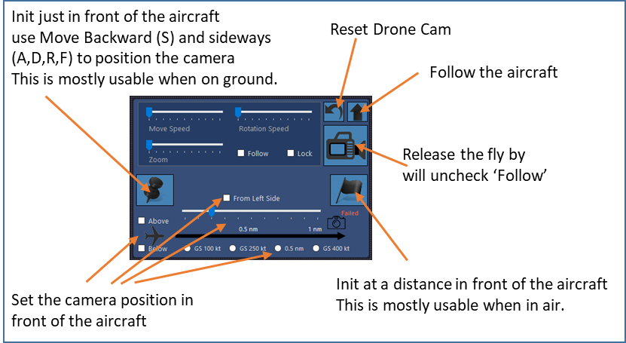

While the app is placing the drone there is a countdown timer instead of the FlyBy Button.  
Please wait patiently until it expires and don’t click the App GUI, otherwise keyboard strokes may get lost.

*Note: the app calculates some vertical offset based on the current vertical rate but may not be at level when the VS changes during the setup.  
Also the cam only moves straight forward from the moment the cam is reset. I.e. in turns the camera is most likely not where it is expected but can make for some interesting flybys.*

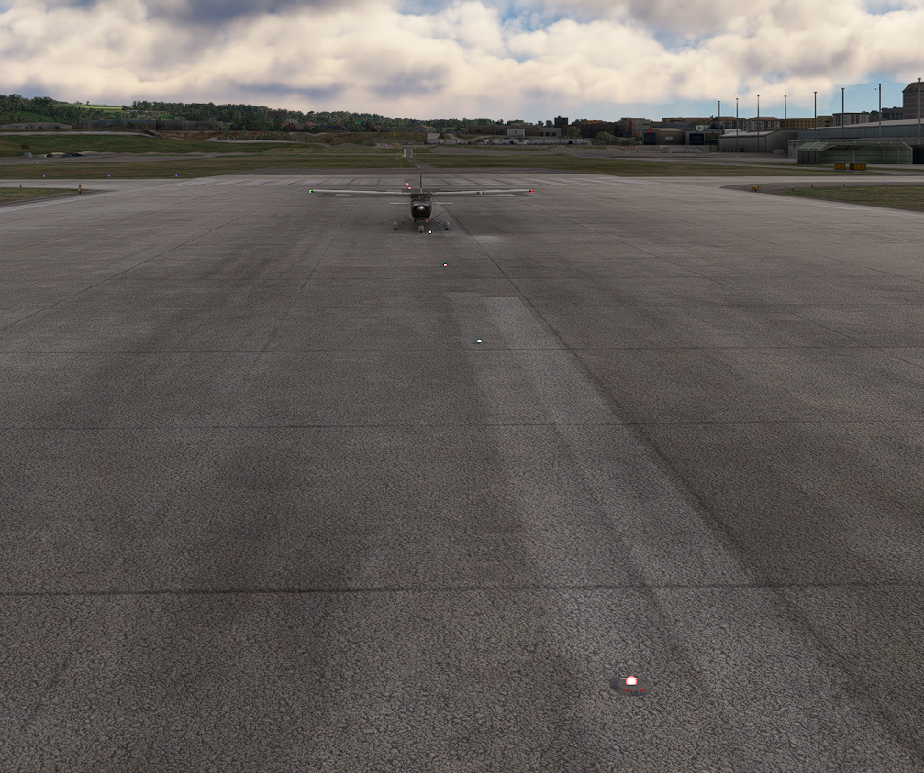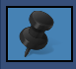Init in front of the aircraft

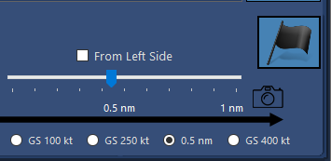

Init 0.5 nm out right side as seen from the aircraft

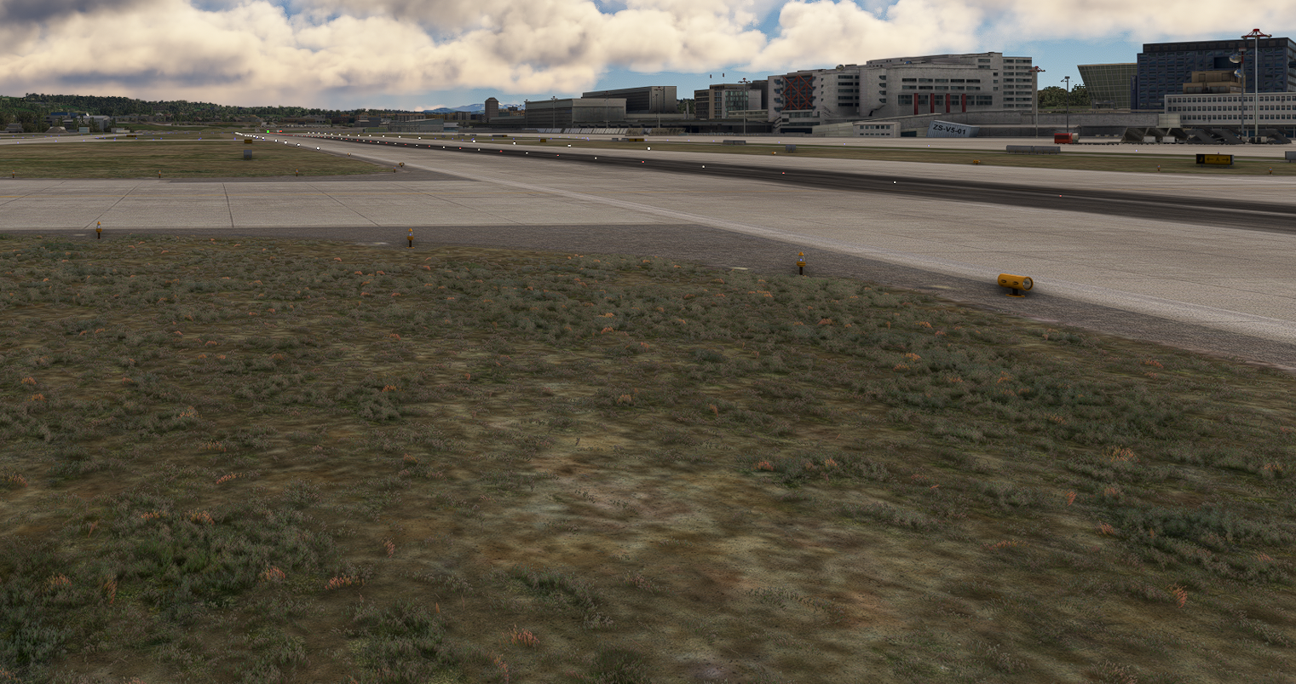

# Key Setup (new V0.70)

In order to be able to issue the right keystrokes to the Sim Window the Camera App needs to know which keys are required – and this is a user setting in MSFS.

The App starts with MSFS defaults:

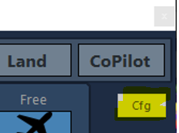Drone Movements: W, A, S, D, R, F (forward, left, backward, right, up, down)

Custom Camera: Left Alt+1 .. Left Alt+0

Use the Key Setup dialog (**Cfg Button**) if you don’t use those defaults and want to change them.  
🡪Settings are saved and it’s only needed once or when changed.

Click **Config…** for the one you want to change, then press the keys required to activate the function.  
Double check the shown key combination for validity – if not OK redo it.  
Click **Accept** or **Cancel** to close and proceed.  
Click **Default** to reset to MSFS Default setting.  
When done with Key Setup, close the Dialog with **Accept** and the settings will be saved and used immediately.  
Else return with **Cancel**, and all changes are ignored.

*Note: in Windows the Alt key is called Menu i.e. ‘Left ALT’ is ‘Left Menu’*

# Distributed Contents:

My FlightSim Libraries (included in the release package)

SEE README.TXT FOR THE LIST

# Appendix:

## Issue Reporting:

In case you encounter a problem please include as much information as possible. Sometimes it is also relevant which aircraft you were using.

To get some helpful information the following procedure will create such output:

Locate where the application is stored (where you extracted the ZIP)

Create a file: HB_DEBUG.txt

Usually **Right click** in the Explorer File list gives you a **New >**  
There choose Text Document and rename it to HB_DEBUG.txt  
It is just an empty file to trigger debug output into a file DEBUG_log.txt

Restart the HudBar and try to reproduce the problem

Exit the HudBar and include the DEBUG_log.txt file in the failure report

It is a plain text file – so you can check the contents for anything you don’t like to be sent out.

Once done you may delete the HB_DEBUG.txt file to no longer create debug output.

Issues can be reported directly via GitHub (or a Message in Flightsim.to)

<https://github.com/bm98/FS20_HudBar/issues>

<https://flightsim.to/file/16604/msfs-hudbar>